EXP NO: 7(a) DATA VISUALIZATION USING TABLEAU
DATE:

AIM:
To connect, analyze, visualize, and create interactive dashboards using Tableau for effective business intelligence and data analytics.
PROGRAM:
1)IMPORTING DATA IN TABLEAU
ALGORITHM:
Step 1: Open Tableau Desktop
Launch Tableau Desktop on your computer.
Step 2: Select Connect
On the start page, click Connect.
Step 3: Choose Excel File
Under To a File, select Microsoft Excel.
Step 4: Browse Dataset
Browse your computer and locate the required Excel dataset.
Step 5: Open Dataset
Select the Excel file and click Open.
Step 6: Verify Imported Data
Check the Data Source page and verify that the dataset has been imported correctly, with the required tables, columns, and data visible.
OUTPUT:
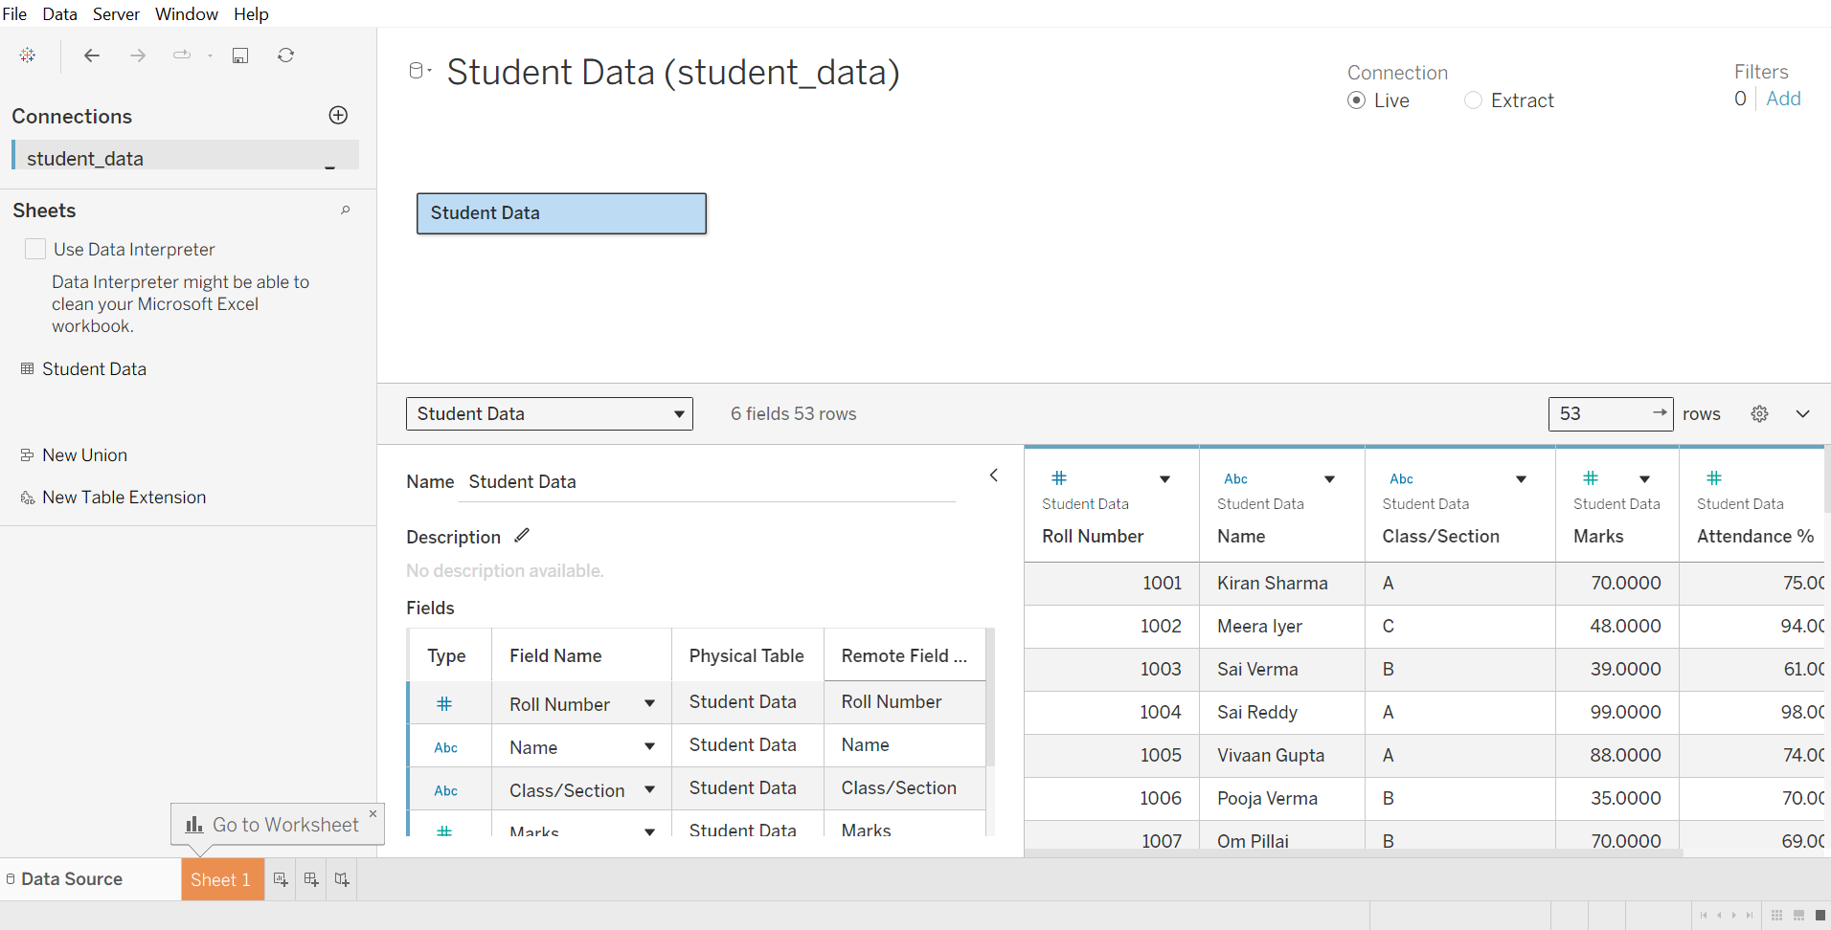
2) BASIC CHART CREATION
ALGORITHM:
• Open Tableau Desktop.
• Connect the dataset to Tableau.
• Create a new worksheet by clicking Sheet 1.
• Select the required fields from the Data pane.
• Drag a Dimension (e.g., Category) to the Columns shelf.
• Drag a Measure (e.g., Sales) to the Rows shelf.
• Choose the required chart type from the Show Me panel, such as a bar chart.
• Verify the chart to ensure the data is displayed correctly.
• Add a title to the worksheet if required.
• Save the Tableau workbook.
OUTPUT: 1) Table view
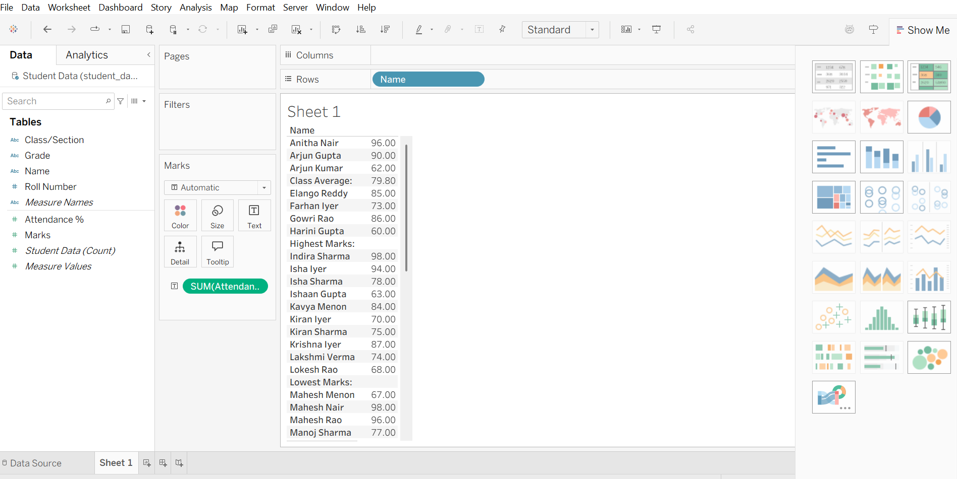
2) Basic Stacked bar chart – Student name vs. attendance
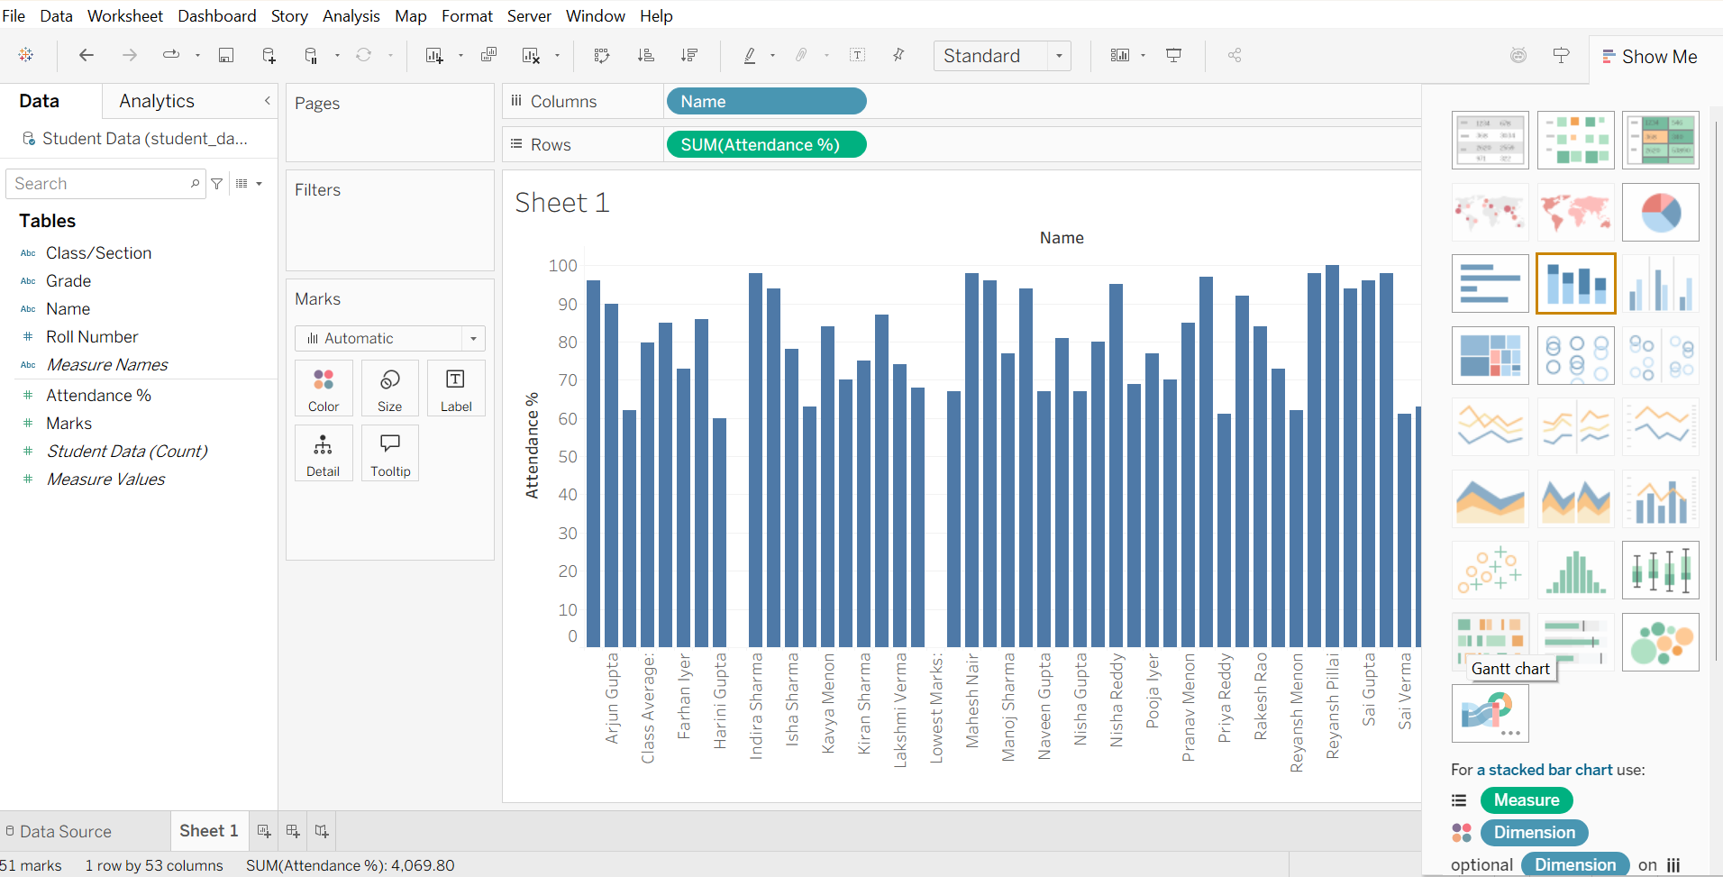
In descending order:
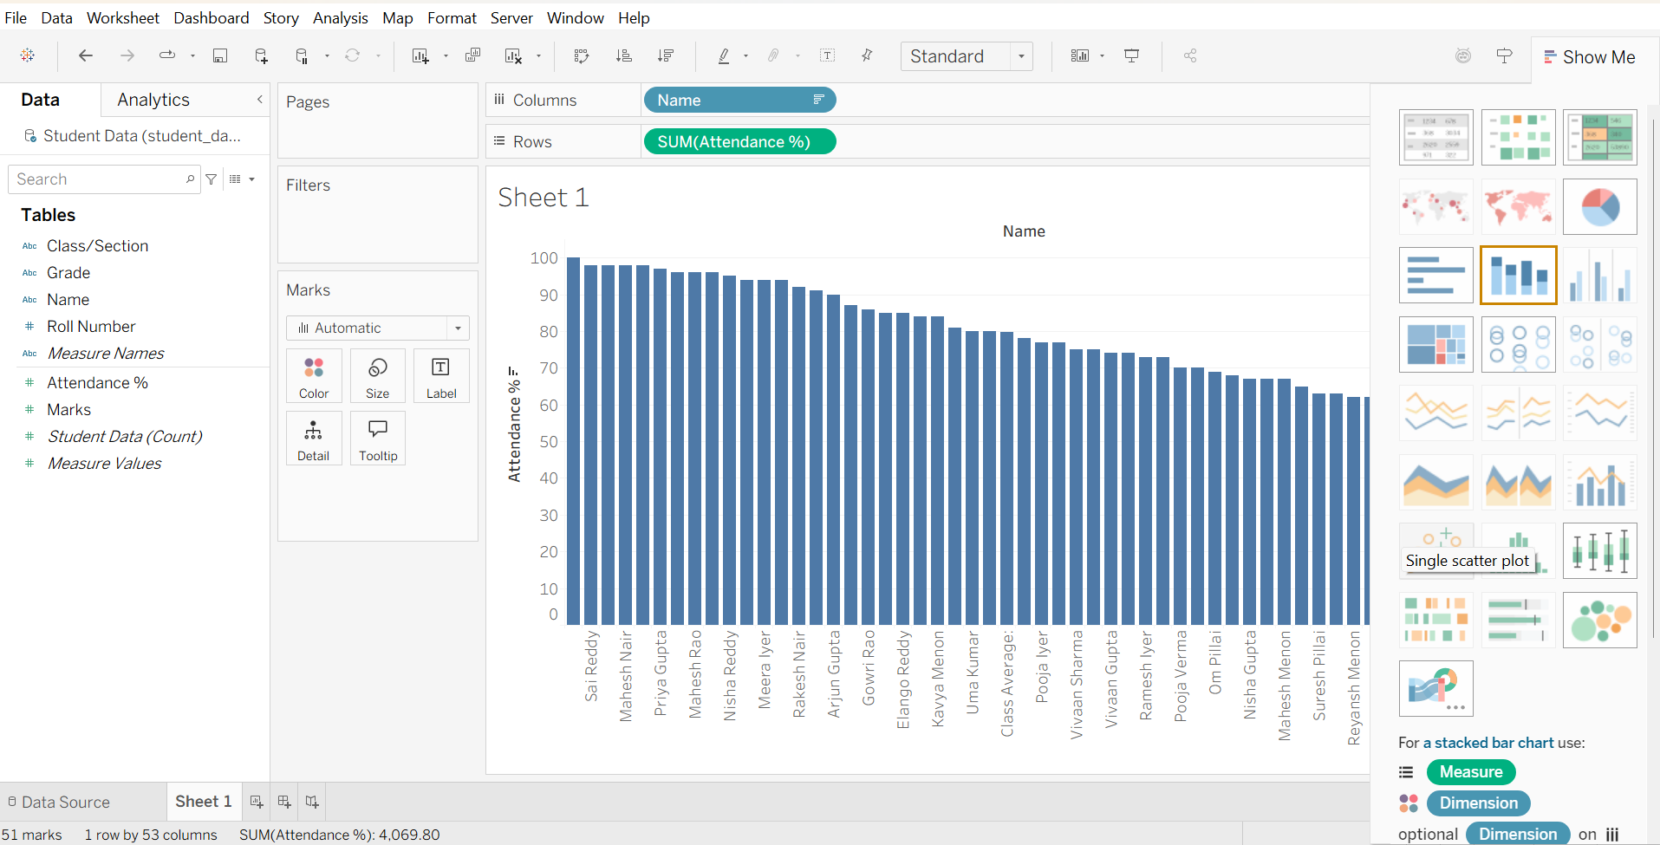

3) APPLYING FILTERS:
ALGORITHM:
- Open Tableau Desktop and open the required worksheet.
- Select the field that you want to filter from the Data pane.
- Drag the field to the Filters shelf.
- Choose the filter type such as:
  - Dimension – select specific categories.
  - Measure – set a range or condition.
  - Date – select a specific date, month, or year.
- Select the required values or conditions.
- Click Apply and then OK.
- Verify the worksheet to ensure that only the filtered data is displayed.
- Save the worksheet with the applied filter.

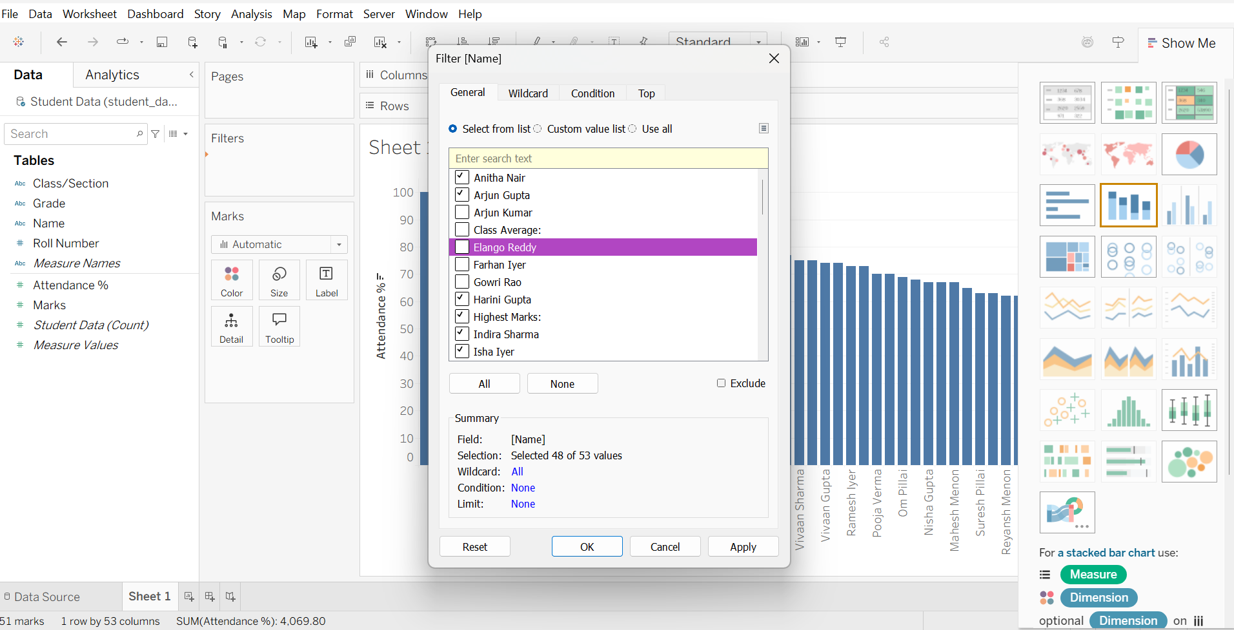
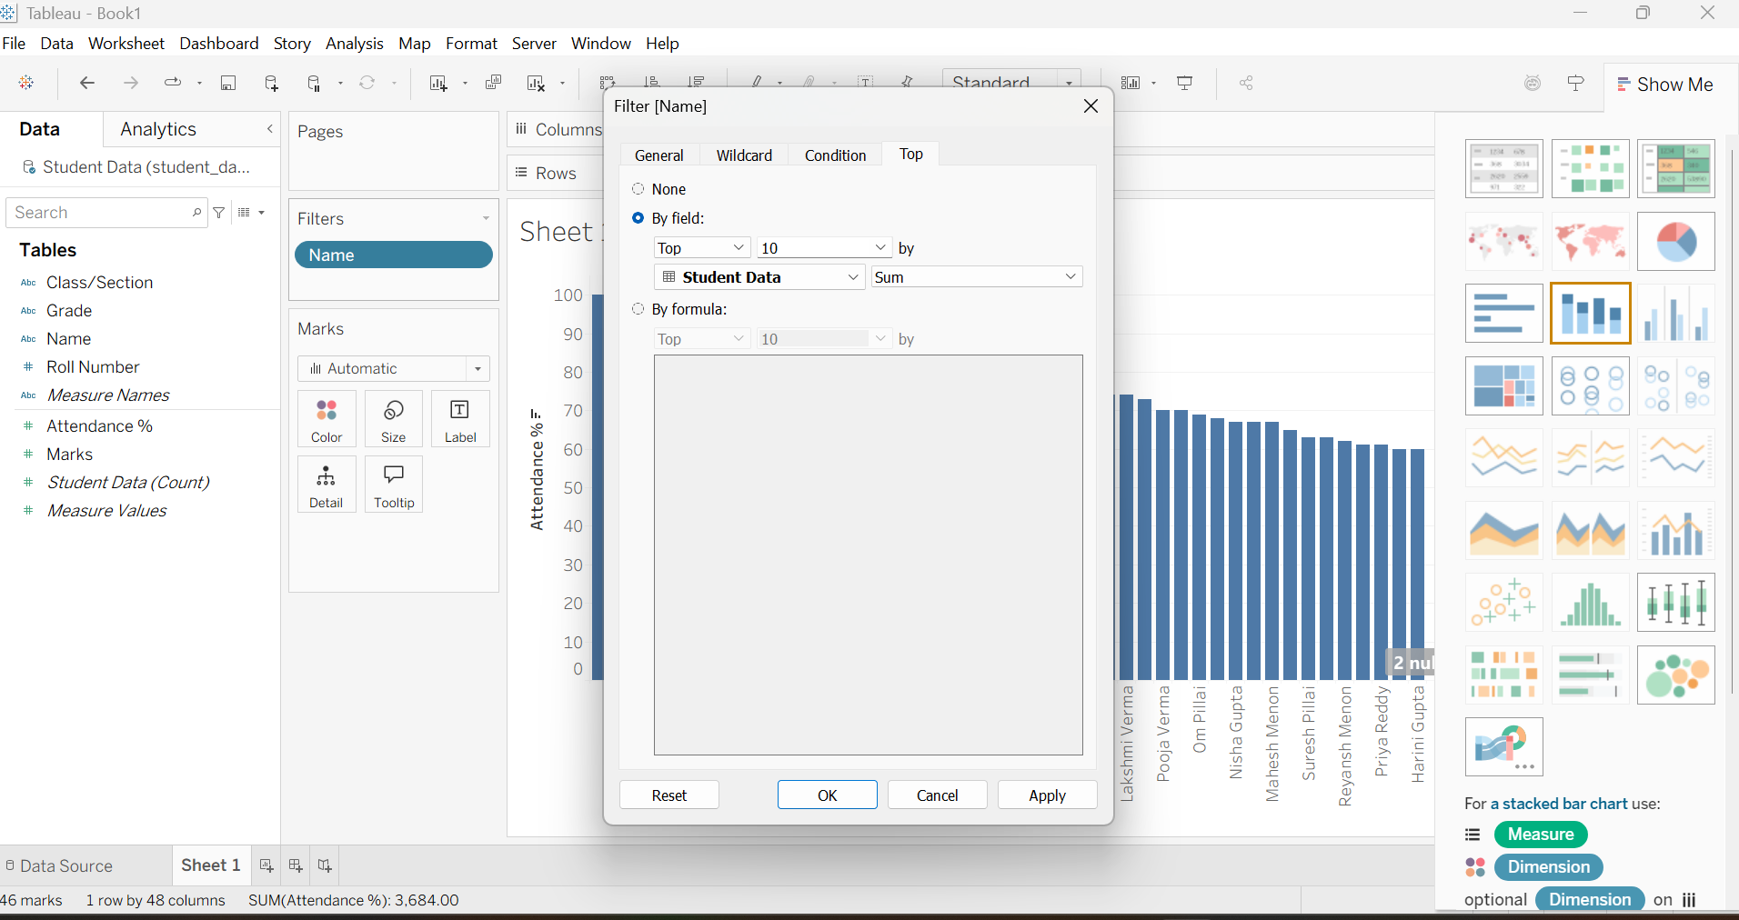
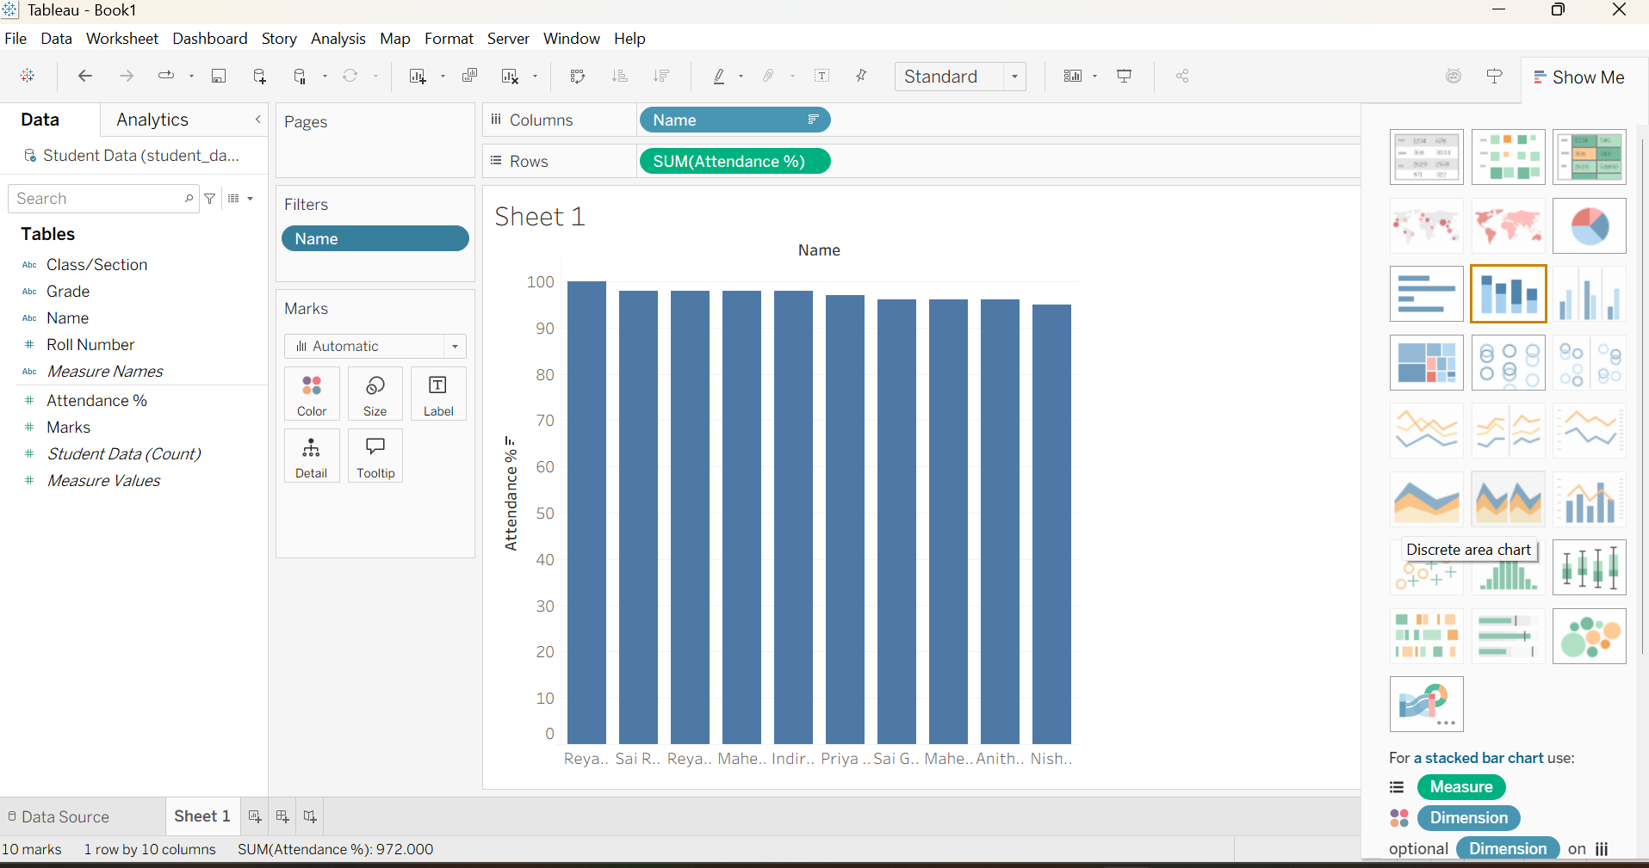
4) OWN CALCULATION FIELD
ALGORITHM:
- Open Tableau Desktop and open the required worksheet.
- In the Data pane, click the drop-down arrow or right-click in an empty area.
- Select Create Calculated Field.
- Enter a name for the calculated field.
- Enter the required formula using available fields, operators, and functions.
- Click OK to create the calculated field.
- The new calculated field will appear in the Data pane.
- Drag the calculated field to Rows, Columns, Marks, or Filters as required.
- Verify the result in the worksheet.
- Save the Tableau workbook.

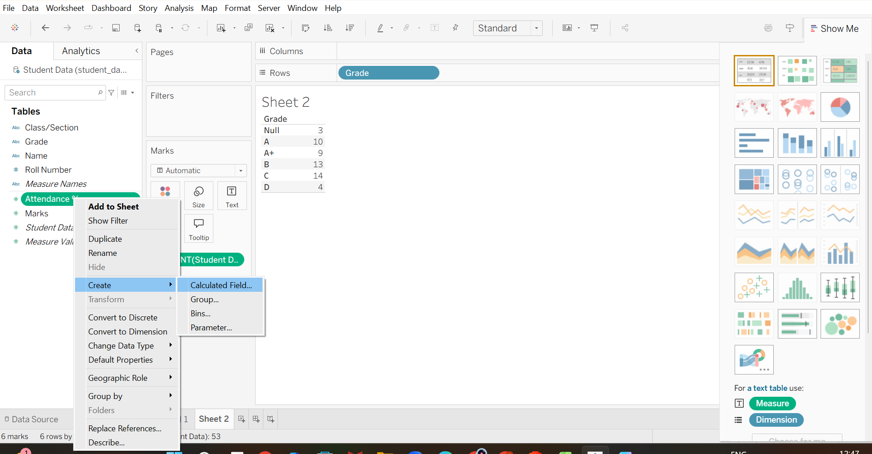
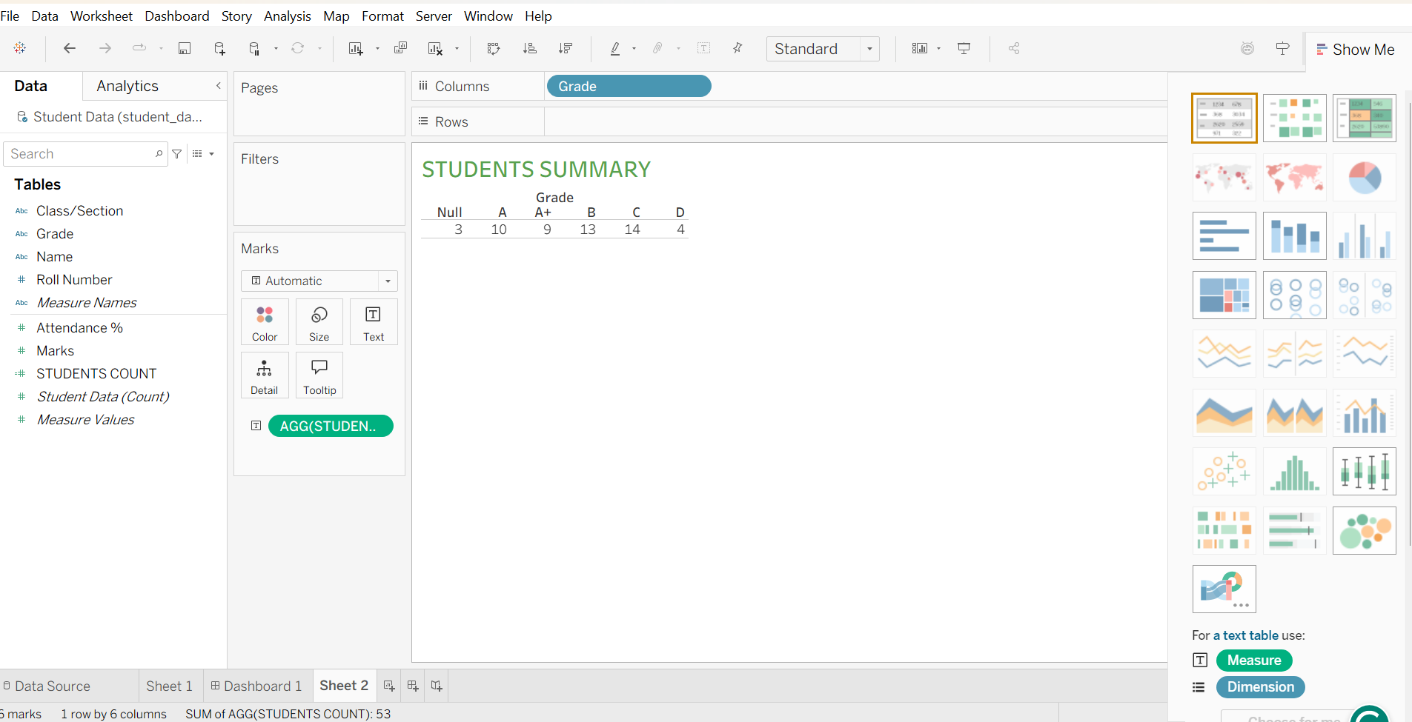
5) PIE CHART:
ALGORITHM:
- Open Tableau Desktop and open the required worksheet.
- Select the dimension and measure required for the pie chart.
- In the Marks card, change the chart type to Pie.
- Drag the dimension to Color to create different slices.
- Drag the measure to Angle to determine the size of each slice.
- Drag the measure to Label if values need to be displayed.
- Adjust the Size of the pie chart as required.
- Verify the pie chart to ensure the data is represented correctly.
- Save the Tableau workbook.

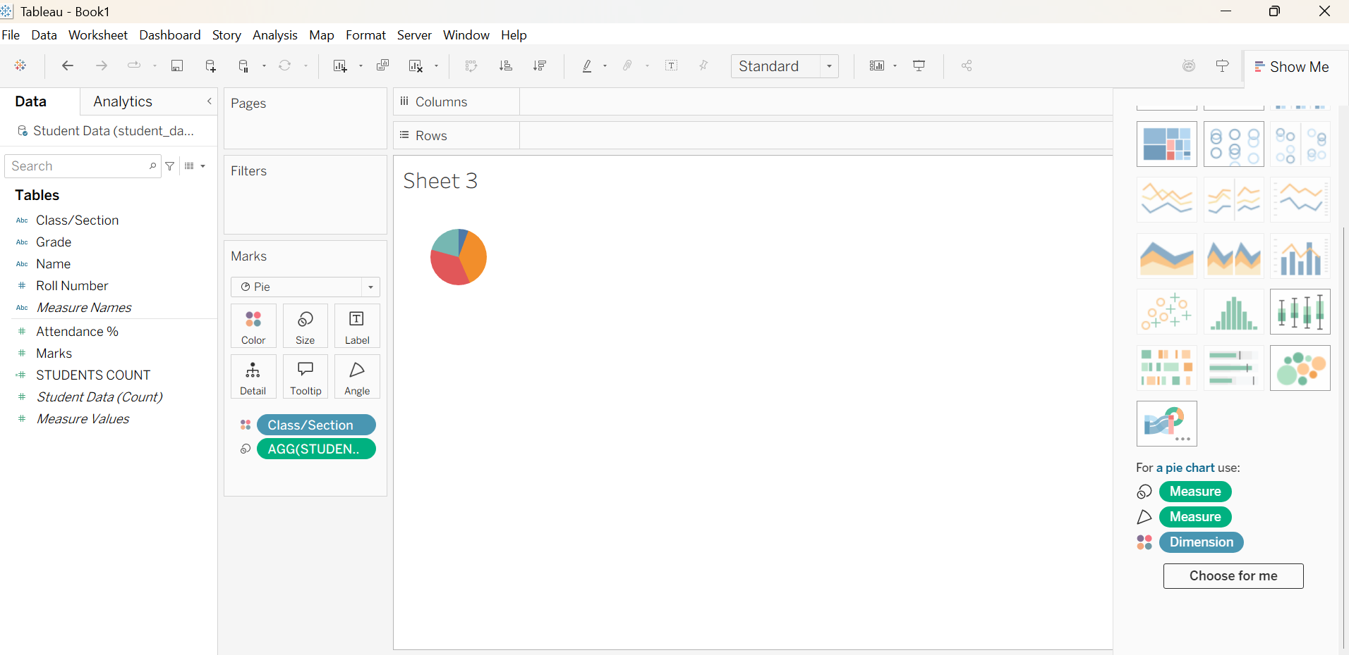
6) LINE CHART:
ALGORITHM:
- Open Tableau Desktop and open the required worksheet.
- Select the required dimension and measure from the Data pane.
- Drag the dimension (e.g., Date) to the Columns shelf.
- Drag the measure (e.g., Sales) to the Rows shelf.
- In the Marks card, select Line as the chart type.
- Use Color to differentiate multiple categories, if required.
- Add Labels to display values on the line, if required.
- Verify the line chart to ensure the trend is displayed correctly.
- Save the Tableau workbook.
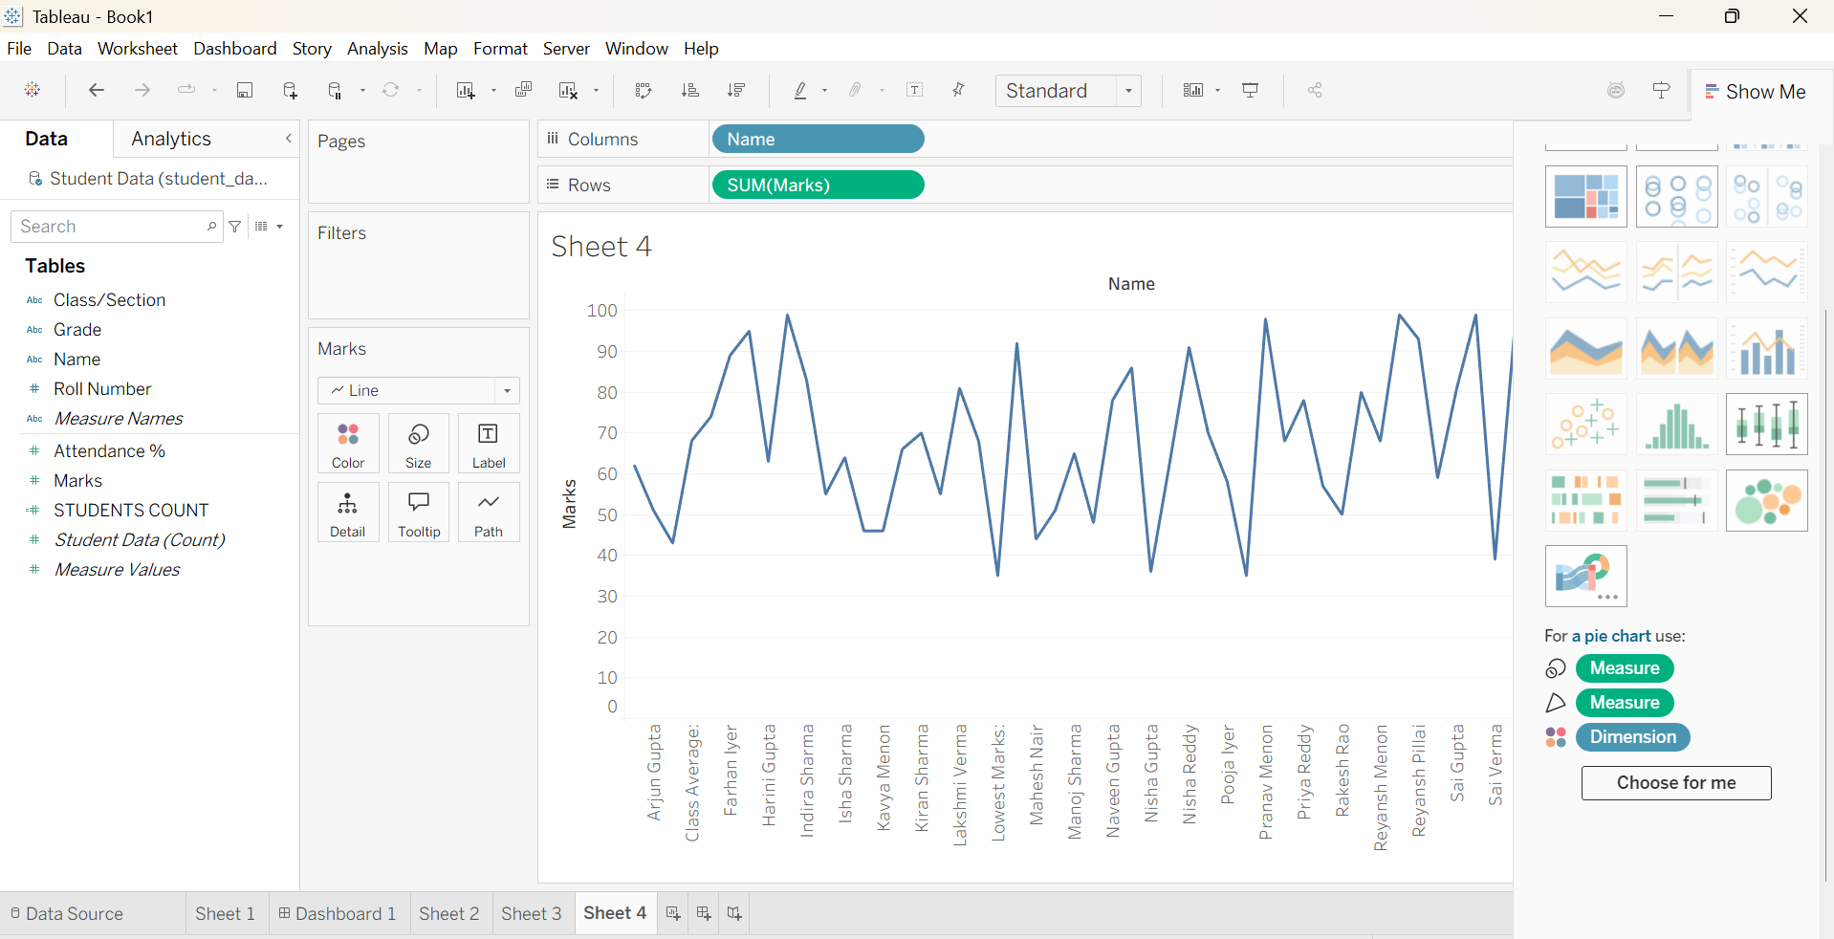
7) BOX AND WHISKER PLOT
ALGORITHM:
- Open Tableau Desktop and open the required worksheet.
- Select the required Dimension and Measure from the Data pane.
- Drag the Dimension to the Columns shelf.
- Drag the Measure to the Rows shelf.
- Click Show Me and select Box-and-Whisker Plot.
- Tableau automatically creates the box plot showing the median, quartiles, and data range.
- Use the Size and Color options in the Marks card if required.
- Verify the plot to identify the distribution and outliers.
- Save the Tableau workbook.
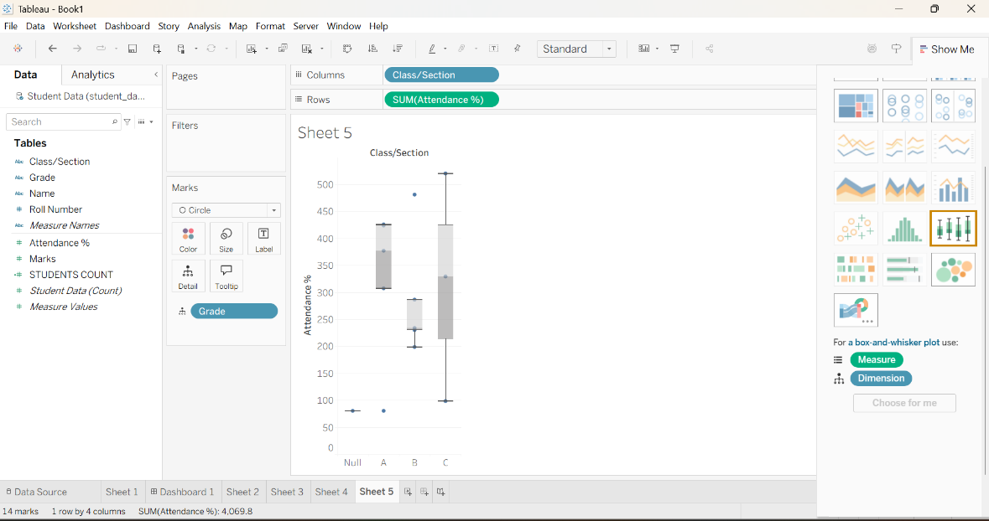

8) CREATING DASHBOARD
ALGORITHM:
- Open Tableau Desktop and open the completed workbook.
- Click New Dashboard.
- Enter a suitable Dashboard Name.
- Drag all the created worksheets into the dashboard.
- Arrange and resize the sheets properly.
- Add required filters, titles, and formatting.
- Verify that all charts and worksheets are displayed correctly.
- Save the dashboard.

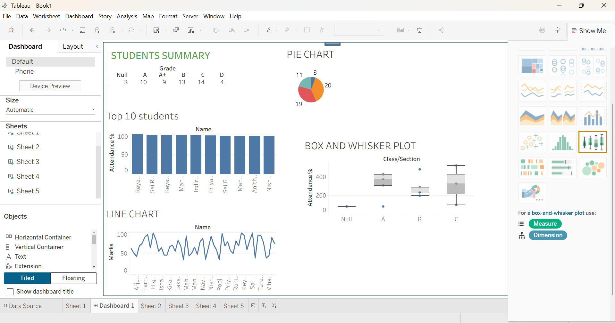

RESULT:

